Use Case Document – CIT360

# Use Case Diagram

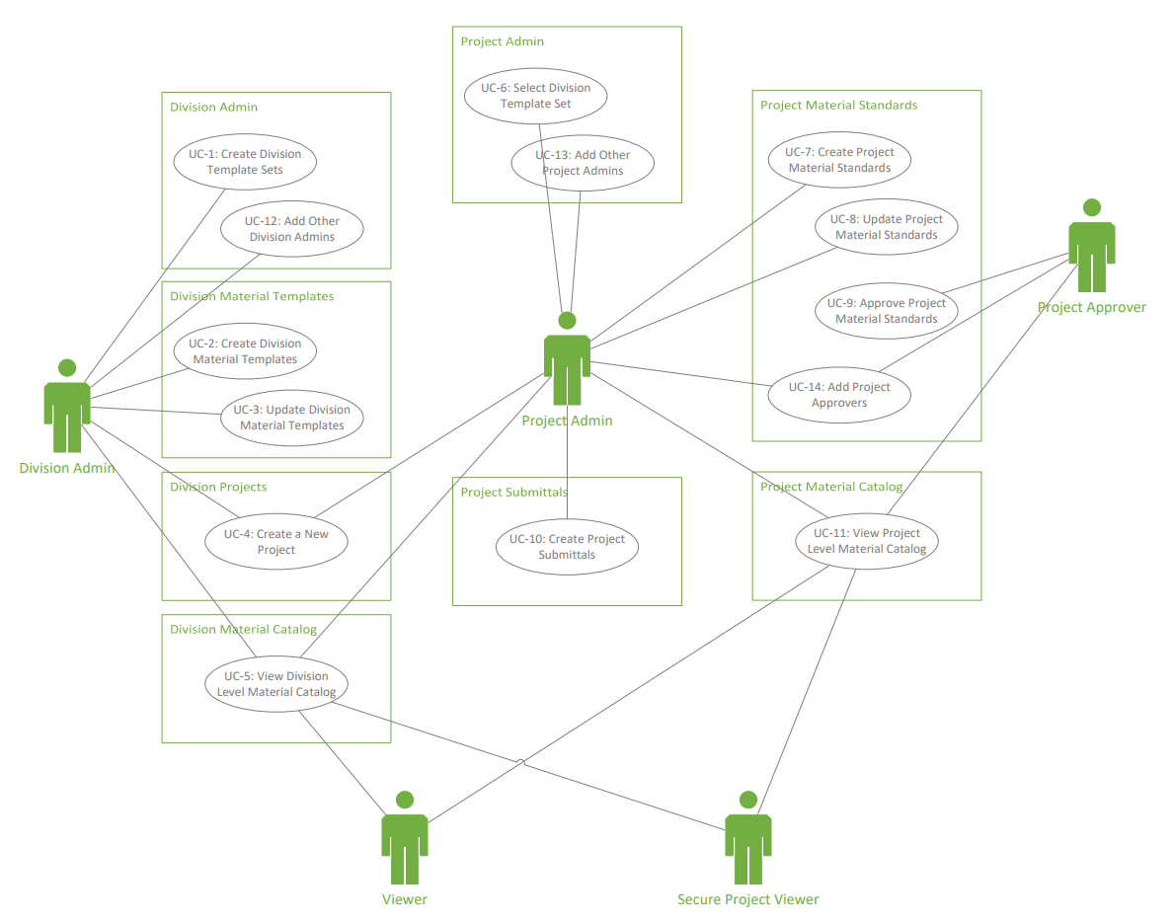

# Use Cases

* 1. Use Case 1: Create Division Template Sets

|  |  |
| --- | --- |
| Use Case ID: UC- 1 Use Case Name: Create Division Template Sets | |
| Actor | Division Admin |
| Description | The division admin creates a division template set by defining a template name and selecting master materials sheets to add to the template. |
| Preconditions | 1. User’s identity has been authenticated 2. User is authorized to create division templates 3. Enterprise-level system is online 4. Enterprise-level master materials sheets are published |
| Postconditions | A division template set is created |
| Normal Course | 1. User navigates to Division Admin module 2. User has the option to create a new division template set 3. User provides a name of the division template set 4. System retrieves all master materials sheets that are available in the enterprise-level repository 5. User selects specific master materials sheets to include in the template set 6. User saves the new template set |
| Exceptions | 1. System blocks creating a duplicated template set name and displays a message to the user 2. User updates the template set name and proceed |

* 1. Use case 2: Create Division Material Templates

|  |  |
| --- | --- |
| Use Case ID UC- 2 Use Case Name: Create Division Material Templates | |
| Actor | Division Admin |
| Description | The division admin configures the details of the division material templates by hiding items on master materials that are not applicable to the division. |
| Preconditions | 1. User’s identity has been authenticated 2. User is authorized to create division templates 3. A division template set exists |
| Postconditions | The master materials sheets in the division template set are configured to become division material templates |
| Normal Course | 1. User navigates to Division Material Template module 2. User selects an existing material template set 3. System retrieves the list of master materials sheets that are added to the template set 4. User selects a master materials sheet and navigates to the page of details 5. User hides material groups and rows that are not applicable to the division 6. User has the option to unhide material groups and rows 7. User saves the division material template 8. User selects another master materials sheet in the template set and continues hiding material groups and rows 9. User completes the configuration of all master materials sheets in the selected material template set |
| Exceptions | None |

* 1. Use case 3: Update Division Material Templates

|  |  |
| --- | --- |
| Use Case ID: UC- 3 Use Case Name: Update Division Material Templates | |
| Actor | Division Admin |
| Description | Division material templates are updated by division admins or updated automatically to stay synchronized with master materials. |
| Preconditions | 1. User’s identity has been authenticated 2. User is authorized to edit division templates 3. A division template set exists and the division templates are created |
| Postconditions | The division material templates are updated. |
| Normal Course | 1. User navigates to Division Material Template module 2. User selects an existing material template set 3. System retrieves the list of master materials sheets that are added to the template set 4. User selects a master materials sheet and navigates to the page of details 5. User hide/unhide material groups and rows 6. User saves to update the division material template sheet |
| Exceptions | None |

* 1. Use case 4: Create a New Project in the Division

|  |  |
| --- | --- |
| Use Case ID: UC- 4 Use Case Name: Create a New Project in the Division | |
| Actor | Division Admin |
| Description | The division admin creates a new project in the division. |
| Preconditions | 1. User’s identity has been authenticated 2. User is authorized to create projects |
| Postconditions | 1. A new project is created 2. A project admin is added to the project 3. The project admin received an email notification |
| Normal Course | 1. User navigates to the Division Projects module 2. System displays the list of existing projects in the division 3. User chooses to create a new project 4. System displays a form that allows the user to provide the required information for the project 5. User fills out the form 6. System saves and creates the new project 7. System sends an email notification to the project admin with a link to the newly created project |
| Exceptions | 1. System displays the warning message in the form and blocks from creating duplicated project names 2. User updates the project name and proceed |

* 1. I can create more if needed.